Humans in cybersecurity

By

Robert Moffett

IT-120B

Marymount University

2-7-20

Abstract and key words

In the video Rachel Botsman explains why trust is the biggest issue in the cybersecurity world. In this paper I am going to talk about why we need to have trust in our people. In the video Botsman talks about how a serial killer was a uber driver. A lot of people had no idea that he was a killer, and that is when we rethink a lot of decisions because we have no idea what people have on there criminal record. She gives is the visual of the trust stack. Being proactive helps the risk of bad things happening. Reactive is when you are there when something goes wrong.

Introduction

Why would people have trust issues in the day we live in today? Well, Botsman explains that sometimes we have no idea what people’s intensions are. Trust is a main key on how we live today because if you cannot trust someone you will be insecure of what you are doing. We always need to be proactive to prevent ourselves to not be in a bad situation. How we build relations is having that trust in one another. There are so many interactions that we can have with random people and that comes with trust. Websites that are meant for finding relationships is a big one. When a person matches with someone, and what to meet up you must have the trust in that person to not harm you or even catfish you. In these situations, you just have to go off of trust signals, which are clues and symbols to make a decision if this person is trustworthy or not

Literature Review

In this video Bortman talks about when her parents found a babysitter and was watching her for 10 months. The babysitter was living in their house, so they had to have a lot of trust in this woman to sleep at there house. Around the 10 months of the babysitter there, she ended up missing one day. She ended up robbing a bank with their Minnie van and arresting her father because she had the family’s car. This family had all the trust in their kid’s babysitter and then shows that she is a bad person to the society. She also gave us the perspective of when the uber driver who did not have background check was able to be an uber driver and ended up killing people as he picked them up for the ride. You would never think that when you are getting an uber that the person is not trustworthy and kill you, but as we know today that people can switch up in a heartbeat.

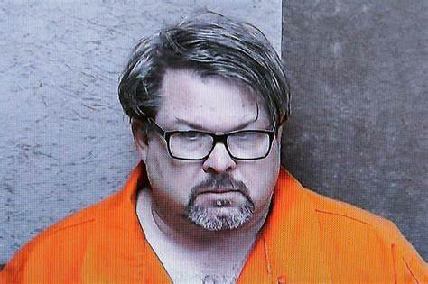

Reflection on topic-

Some things I have gotten from is that one you must have to have trust to live your life. She gave us the example when her parents hired a babysitter for 10 months and her babysitter ended up being one of the biggest drug dealers. Her parents gave the trust to this woman and acted like she was a good person, but when no one was looking she was doing bad things. When she started talking about how when the uber driver ended being a serial killer made me rethink on getting a uber. We have no idea what that person is going to do and cannot change anything in that moment. The question is how this guy could be an uber driver, and the uber owner said that his stars were good. Technology is making everything in this world to have trust in one another. This relates to cybersecurity because we have apps on our phones that give away personal information.

Conclusion

In conclusion trusting one another is the way we must live in our world today. With all the technology we have is scary for us people because there is a lot more personal information must put out for everyone to see. Having trust in people around makes everything less stressful, but should not panic in a bad situation where you are not having trust.

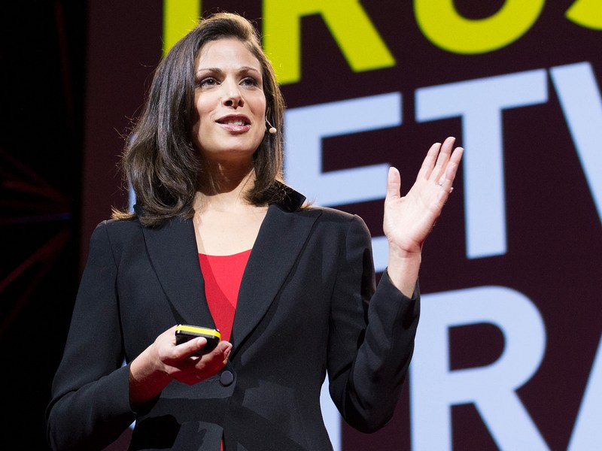

Citations

Kramer, |. (2016, November 30). Trust: Humanity vs. technology. Retrieved February 08, 2021, from <https://bryankramer.com/trust-humanity-vs-technology/>

Wisseman, S. (2019, February 05). Broken promises: How trust affects cybersecurity. Retrieved February 08, 2021, from <https://techbeacon.com/security/broken-promises-how-trust-affects-cybersecurity>

Trust stack. (n.d.). Retrieved February 08, 2021, from https://trustcentral.com/trust-stack/